
IDH1 (R132P)
Catalog Number: CR-M26406
Gene Symbol: IDH2; D2HGA2; ICD-M; IDH; IDHM; IDP; IDPM; mNADP-IDH
Description: Anti-IDH1 (R132P) Mouse Monoclonal Antibody

Background: Isocitrate dehydrogenases (IDH) catalyze the oxidative decarboxylation of
isocitrate to 2-oxoglutarate. Mutations affecting Arg-132 are tissue-specific, and suggest that this residue plays a unique role in the development
of high-grade gliomas. Mutations of Arg-132 to Cys, His, Leu or Ser abolish magnesium binding and abolish the conversion of isocitrate to
alpha-ketoglutarate. Instead, alpha-ketoglutarate
is converted to R-2-hydroxyglutarate. Elevated levels of R-2-hydroxyglutarate are correlated
with an elevated risk of malignant brain tumors.
Immunogen: A synthetic peptide from the internal region of IDH1 which includes the mutation of R132P, human origin.
Tested applications: ELISA, WB, IHC Recommended dilutions:
ELISA: 1:1000-1:5000
WB: 1:100-1:1000
IHC: 1:50-1:100
Concentration: 1 mg/ml
Host: Mouse
Clonality: Monoclonal
Purity: Purified from ascites
Format: Liquid Storage buffer:
Preservative: no
Constituents: PBS (without Mg2+ and Ca2+), pH 7.4, 150 mM NaCl, 50% glycerol
Species Reactivity: recognizes R132P mutant, but not wild-type IDH2 of vertebrates.
Storage Conditions: Store at -20°C. Avoid freeze / thaw cycles.

Western blot:

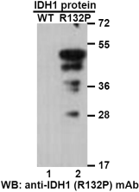

Western blot analysis of recombinant IDH1 (R132P) and wildtype proteins. Purified
His-tagged IDH1 (R132P) (lane 1) and
corresponding wild-type IDH1 protein (lane 2)
were blotted with anti-IDH1 (R132P) monoclonal antibody (Cat. #26406).

For research use only. Not for diagnostic or therapeutic applications.

Immunofluorescence:
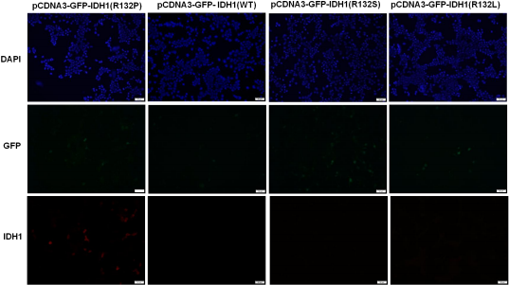
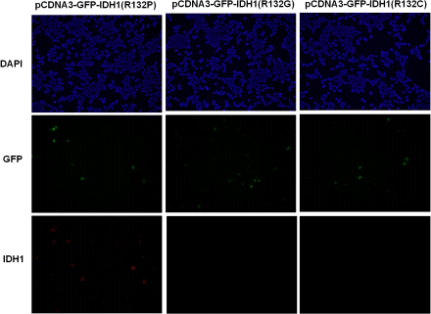
Immunofluorescence of cells expressing IDH1 proteins with anti-IDH1 (R132P) antibody. HEK293T cells were transfected with
pCDNA3-GFP-IDH1(R132P) plasmid, pCDNA3-GFP-IDH1 (WT) plasmid ,
pCDNA3-GFP-IDH1(R132S) plasmid, pCDNA3-GFP-IDH1(R132L) plasmid ,
pCDNA3-GFP-IDH1(R132G) plasmid or pCDNA3-GFP-IDH1(R132C) plasmid , then fixed and stained with anti-IDH1 (R132P) monoclonal antibody (Cat. #26406).

科博瑞（武汉）生物科技有限公司
TEL：027-87615885 15972062685
- mail：3636901710@qq.com
Web:www.coburybio.com

